Instructions for Turnup glider build
- If possible it is recommended to cut out the parts prior to the meeting. Remember we need to be done by 9PM.
- Materials needed-3/32 balsa for the wing, 1/8 balsa for fuselage, 1/32 balsa for stabilizers, use the lightest wood you can find. We will assemble with CA and accelerator. Exacto knife. Ruler, w/straight edge, pencil or pen, masking tape. If you want to build a pop pod, bring a 9 inch piece of BT5 and a launch lug..
- If you want to air foil your wings at the meeting bring a sanding black and a “surface” to work on. I will have a set of presanded wings for the assembly demo. If you want to do this before the meeting it will save you some time. (see included photos of how I do it). I will also demo a quick technique for this.
- It is good if you have small block of wood or something to hold the fuse vertical while glueing stuff on. I use testors enamel bottles, I will bring a few.
- Photos of wing sanding
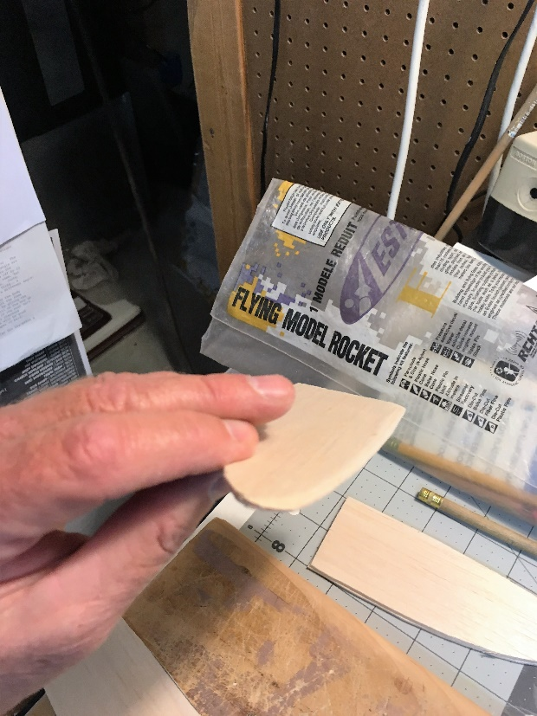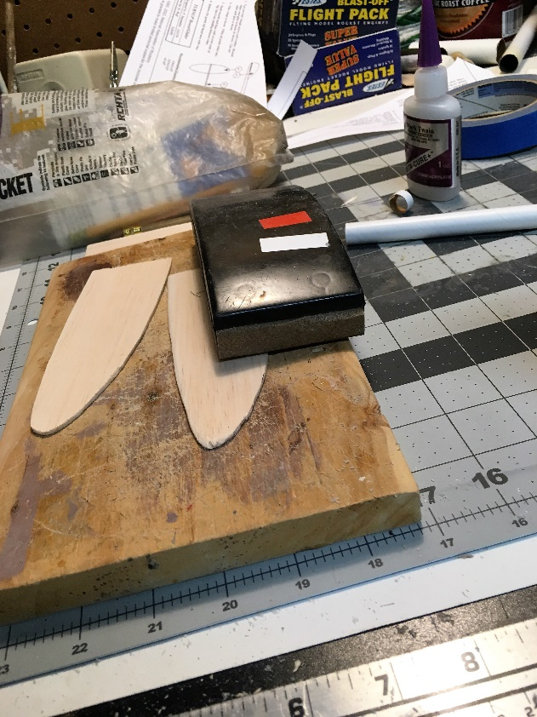

Wing airfoil sanding
- Round the leading edge with your sandpaper
- Taper the trailing edge by sanding at a shallow angle.
- Continue to sand the leading and trailing edge until you get the tear drop airfoil shape. You are striving for a asymmetric airfoil;, the bottom will be flat. Take your time and don’t be too aggressive. You can always take more off, you can’t put it back.
- Put the two wings together, and compare. Make adjustments as needed.
